***i-Recovery Application Architecture :***

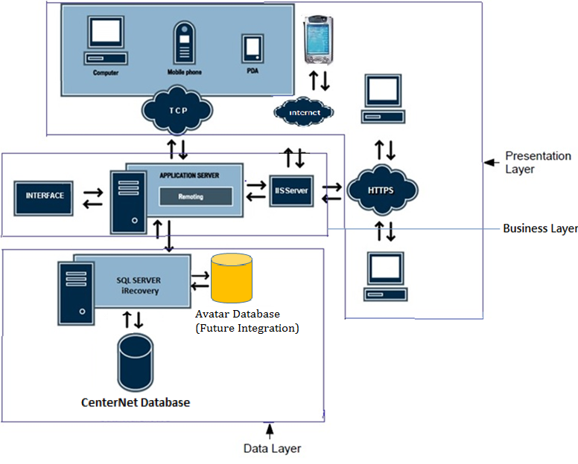

***i - Recovery Architecture:***

* **Presentation Layer (Angular 2.0)**
* **Application Layer (IIS Server)**
* **Database Layer ( SQL Server)**
* **The Presentation Layer**
  + GUI only
  + At workstation
  + Very light
  + Sends requests to application server
  + Obtains screens from application server and displays
* **The Database Layer**
  + Interface between application server and RDBMS
  + SQL Server/Also holds the Other specific DB
* **The Application Server**
* Dedicated Servers are linked by Communication Networks

***iRecovery Health Monitoring Diagram:***

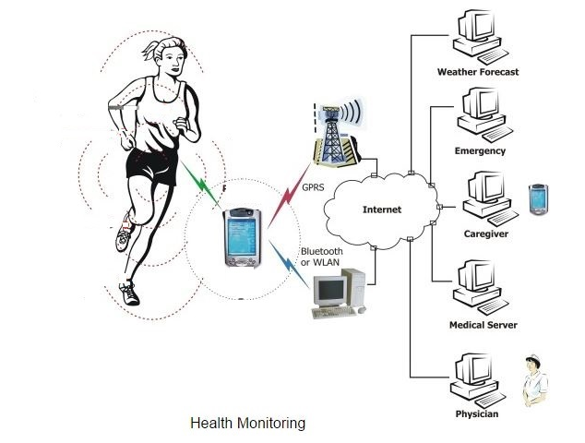

***iRecovery Operational Model – System View***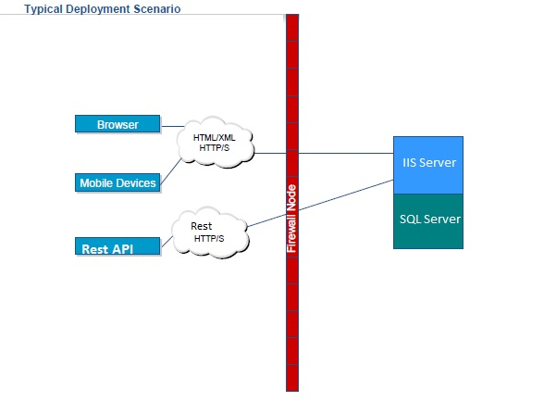

***iRecovery Operational Model – System View***

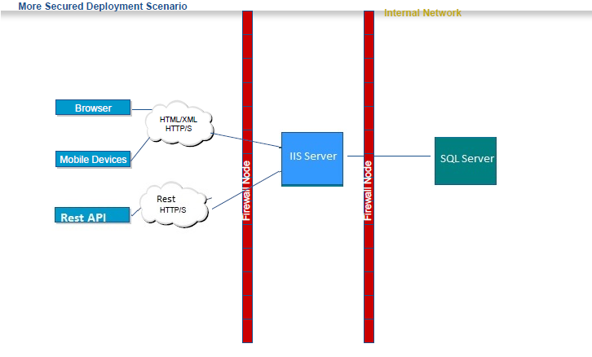

***iRecovery Operational Model – Software View***

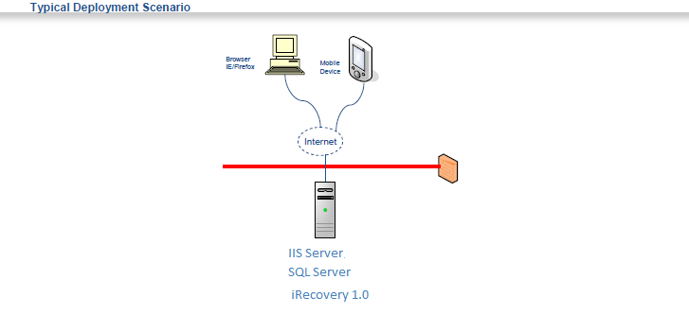

***iRecovery Operational Model – Software View***

